Ch21
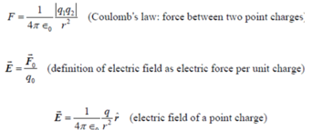
Mechanical waves 机械波 传播速度v = $\sqrt{\frac{E}{ρ}}$ (?)
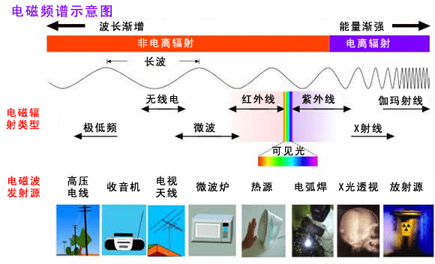
gravitational interactions 引力相互作用
(Universal gravitational force万有引力 $\vec{F}=-\frac{Gm_{1}m_{2}}{r^{2}}\hat{ r}$ )
electromagnetic interactions 电磁相互作用
the strong interaction 强相互作用
the weak interaction 弱相互作用
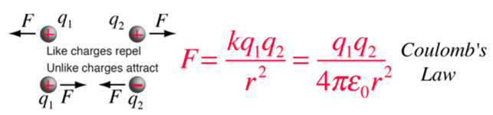
-Electric field due to aa point charge
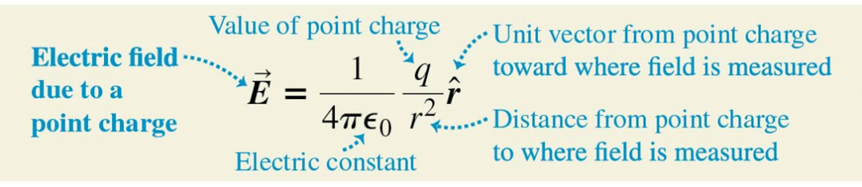
- $ϵ_{0}=8.854×{10}^{-12} F·m^{-1}$
- $4 π ϵ_{0}=k=9×{10}^{9}N·m^{2}/C^{2}$
spacing(n.)间距
superposition (n.)叠加
-Electric dipole
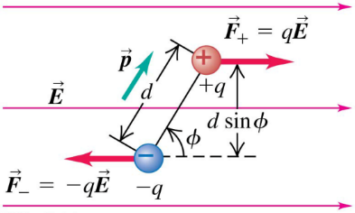
Electric dipole moment $p=q d$
Unit: C·m
Torque for a dipole in an electric field
- $\vec{τ}=\vec{p}×\vec{E}$
Potential energy for a dipole in an electric field
- $U=\vec{p}∙\vec{E}$
Ch22
- Electric flux电通量
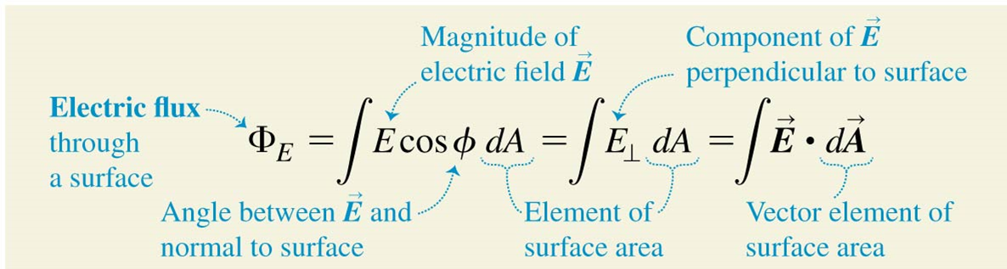
单位: N ∙ m²/C.
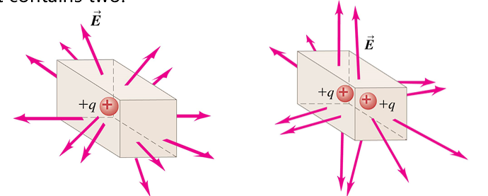
The net electric flux 净电通量
与面内的净电荷 成正比，
is independent of 面的大小 (无关)
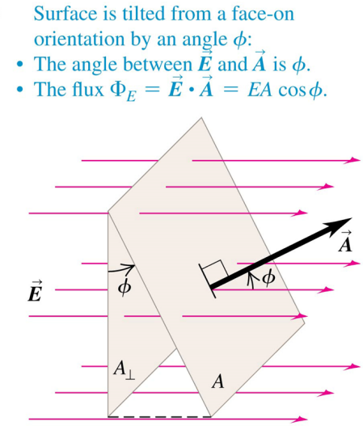
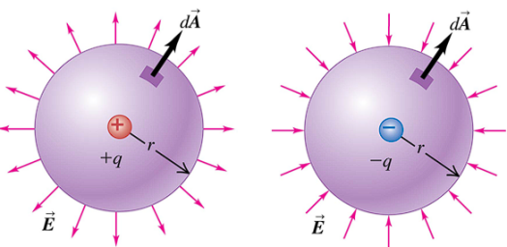
(+) positive (outward) flux 正-向外
(-) negative (inward) flux 负-向内

- Gauss’s Law: 高斯定律是表面上 所有点
_的电场 与 表面内的_总电荷 _之间的 关系
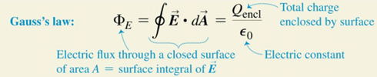
导体内部：E=0 everywhere → Q_{encl}=0 → 电荷在表面
electrostatic conditions: charges not in motion
Spherical shell ; Non-Conducting Solid Sphere
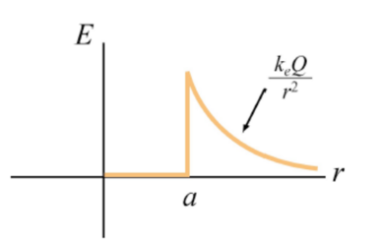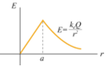
Field of a uniform line charge 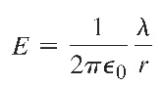
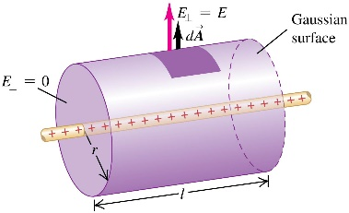
Field of an infinite plane sheet of charge
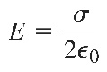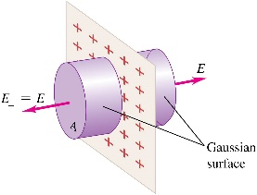
Field at the surface of a conductor
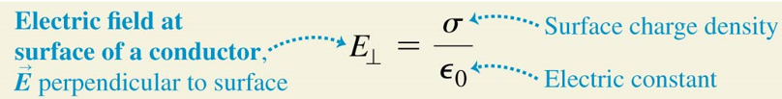
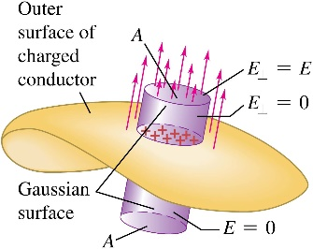
导体上的一片电荷产生的场与仅仅一片电荷产生的场不同：因为电荷片的两边都有电场，而导体只有外部有电场
Electrostatic shielding电磁屏蔽: 导体壳内部E=0，电荷正负分别分布于表面左右
内部有空腔的实心导体：内表面电荷必为内部存在的电荷的相反数
Ch23
- Electric potential energy
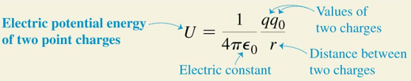
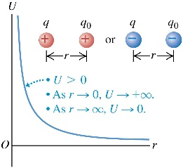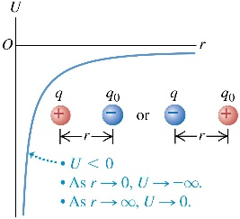
Electric potential V_{ab} = V_{a} – V_{b}
单位电荷从 A 移动到 B 时电力所做的功
The potential due to a collection of point charges:
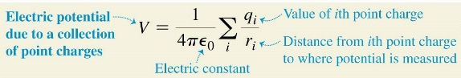
Electrical potential with several point charges
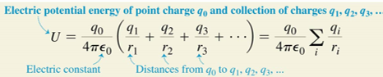

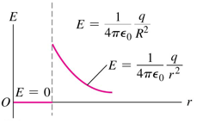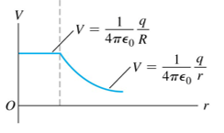
equipotential surface 等势面
导体的表面始终是等电位表面。
导体外的电场总是垂直于导体表面
U_{a} − U_{b} = q (V_{a} − V_{b})
1 eV = 1.602 × 10⁻¹⁹ J
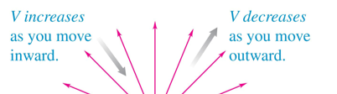
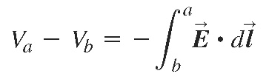
1 N/C = 1 V/m
- Potential gradient 电位梯度
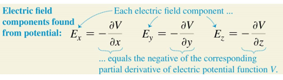
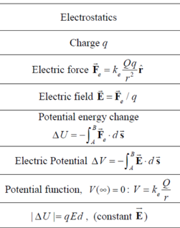
Ch24
$C=\frac{Q}{V_{ab}}=\frac{Q}{Ed}=ε_{0}\frac{A}{d}$ (in vacuum)
1F = 1C²/N·m = 1C²/J
1V = 1C/J → 1F = 1C/V
1C²/N·m² = 1F/m
→ $ε_{0}=8.85×{10}^{-12}F/m$
The potential energy stored in a capacitor:
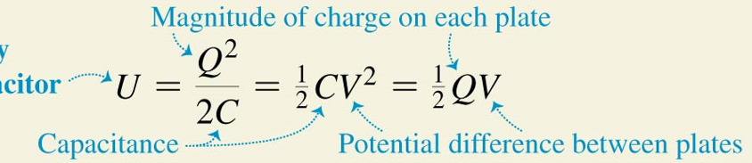
work to charge a capacitor
· $dW=v dq=\frac{q dq}{C}$
$$W_{total}=\int_{0}^{W_{total}}{dW}=\frac{1}{C}\int_{0}^{Q_{final}}{q dq}=\frac{Q_{final}^{2}}{2C}$$
=the total work done by the electric field on the charge
when the capacitor discharges放电

The energy density:
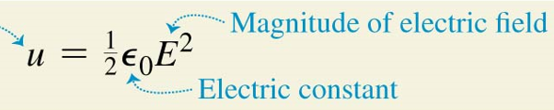
串联电路 series:
· $V=V_{1}+V_{2}$
· $\frac{1}{C_{eq}}=\frac{V}{Q}=\frac{1}{C_{1}}+\frac{1}{C_{2}}+\frac{1}{C_{3}}+⋯$
并联电路 parallel:
· Q = Q₁ + Q₂
· $\frac{1}{C_{eq}}=\frac{V}{Q}=\frac{1}{C_{1}}+\frac{1}{C_{2}}+\frac{1}{C_{3}}+⋯$
Electric energy density in a vacuum:
· $u=Energy density=\frac{\frac{1}{2}CV^{2}}{Ad}=\frac{1}{2}ε_{0}E^{2}$
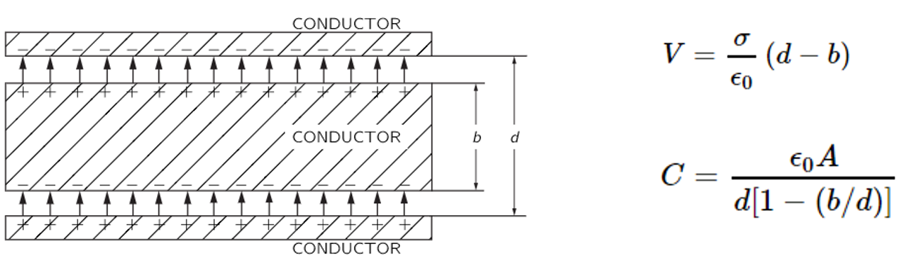
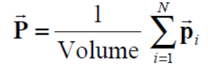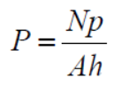
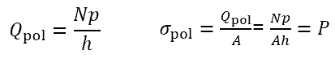
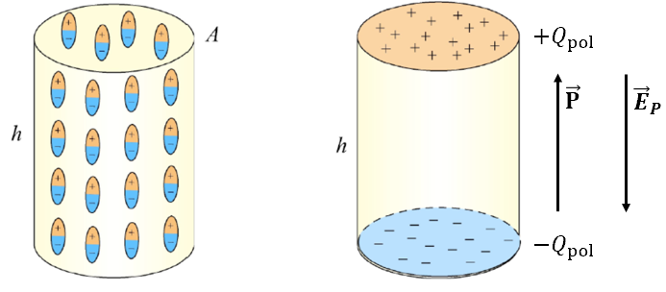
The dielectric constant K
· $ε={K ε}_{0}$ (in vacuum K=1)
Dielectrics电介质: nonconducting material
Dielectric breakdown 介电击穿
dielectric strength: the maximum electric field……
- The force on a dielectric thin film
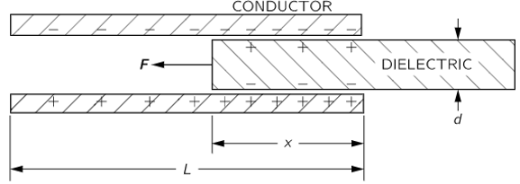
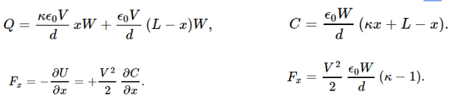
Ch25
电流 ·$I=\frac{dQ}{dt}=n \left|q\right|{ v}_{d }A$
·$v_{d}=τ a=qEτ/m$
n: Concentration of moving charged particles 移动带电粒子的浓度
|q|: Charge per particle 每个粒子的电荷
- The total current I : is found by adding up the currents due to each kind of charged particle.
-Current density 电流密度
· $\vec{J}=n q \vec{v_{d}}$
矢量 电流密度J 的方向 始终 与 矢量 电场E(?) 的方向 相同，无论电荷载流子的符号是什么
-Resistivity (ρ) 电阻率
·$ρ=\frac{E}{J}$ (电场大小/电流密度大小)
Conductivity (σ) 电导率
·$σ=\frac{1}{ρ}$
The resistance电阻 of a conductor:
· $R=\frac{ρL}{A}$
· $V=IR$
电流从 较高电位 流向 较低电位 (电流流向与电势)
在给定温度下，电流与电压成正比
-Nonohmic resistors 非欧姆电阻器
电压与电流的关系可能不是 成正比的，
对于 电流的两个方向(!!)，电压与电流的关系可能不同。
semiconductor diode半导体二极管
diode (n.)二极管
温度T↑，电阻率ρ↑
· $ρ(T)=ρ_{0}[1+α(T-T_{0})]$
α: Temperature coefficient of resistivity
-Thermistor (n.)热敏电阻
温度T↑，石墨的电阻率ρ↓
-Superconductivity (n.)超导性
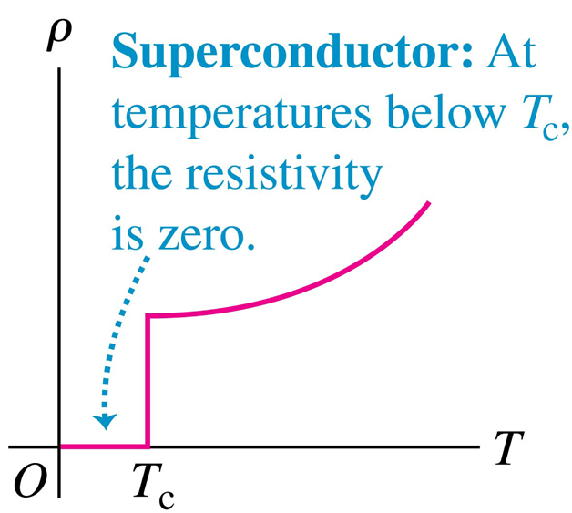
phase transition相变
- Electromotive force (emf) (Ɛ) 电动势
1V = 1J/C
Terminal voltage端电压
·$V_{ab}=Ɛ-Ir$
Power 功率·$P=V_{ab}I$
Ch26
-Kirchhoff’s rules 基尔霍夫定律
·$\sum{I_{in}=}\sum{I_{out}}$
·$\sum_{closed loop }{ΔV}=0$
电容器充电时：
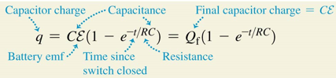
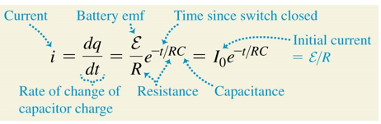
电容器放电时：
